AS3959

Obtaining a developed wind flow

* The distance between the inlet and the starting of forest = 120 m
* Set up velocity device at every 10 m interval.
* Inlet wind velocity: SEM method

|  |
| --- |
|  |
| |  | | --- | | 1.5 m 🞨 1.5 m 🞨1.5 m. Inlet velocity is 20.71 m/s. | |

**At X=-45 m distance U10 =19.4613 m/s. Requirement is 19.44 m/s.**

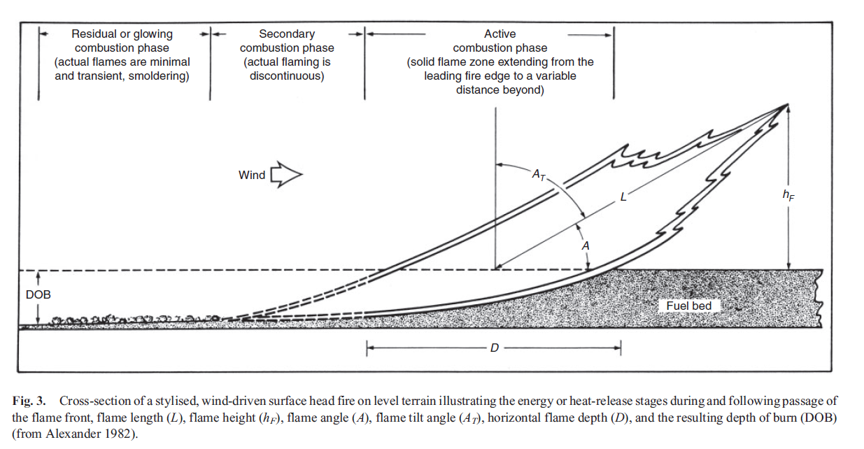Depth of the Fireline

According to Alexander et al [1], Flame depth:

**D= r.tr**

Where r is rate of spread and tr is residence time. As per Wotton et al [2], Average flame front residence time for eucalypt forest fuels was **37 s** and did not vary significantly with fine fuel moisture, fuel quantity or bulk density.

|  |  |  |  |  |
| --- | --- | --- | --- | --- |
| Vegetation classification | ROS | | tr | Flame depth  (m) |
| Km/h | m/s |
| **Forest** | **1.493** | **0.414** | **37** | **15.3** |
| **2.384** | **0.662** | **37** | **24.5** |
| **3.013** | **0.837** | **37** | **30.9** |
| Scrub | 4.555 | 1.265 | 45 | 56.9 |
| 7.441 | 2.066 | 45 | 92.9 |
| 8.966 | 2.491 | 45 | 112.1 |
| Mallee/Mulga | 4.555 | 1.265 | 45 | 56.9 |
| 7.441 | 2.066 | 45 | 92.9 |
| 8.966 | 2.491 | 45 | 112.1 |

**Scrub & Malle/Mulga residence time? 20 s? (pending)

**Find would be the flame depth for Filkov’s work?

Fire spread rate = 0.289 ±0.014 m/s (considering 5% uncertainty of estimation of arrival time from the video)

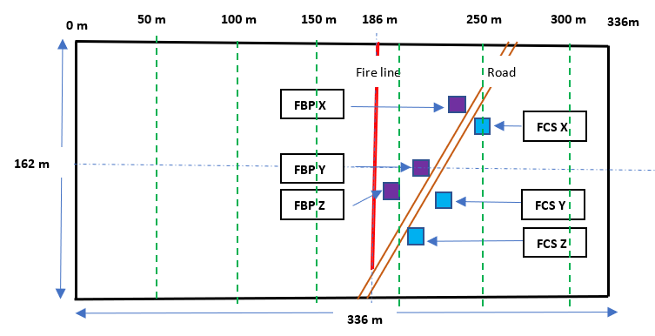

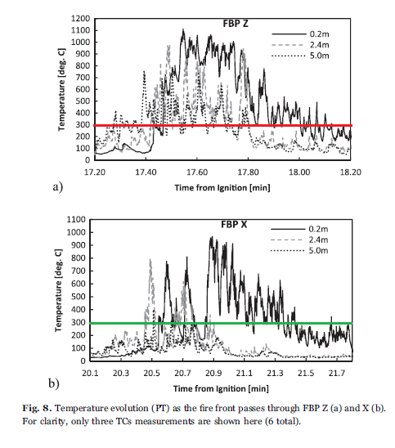

Tr profile at0.2 m height was considered to avoid the effect of radiation of the flame.

|  |  |  |  |
| --- | --- | --- | --- |
| Location | ROS (m/s) | Tr (seconds) | Fireline depth (m) |
| FBP Z | 0.289 | (18.12-17.43)🞨60 s = 41.4 | ≈12.0 |
| FBP X | 0.289 | (21.67-20.55)🞨60 s = 67.2 | ≈19.5 |

AS3959 Firebrand generation source term calculation based on the **species, FMC,** and **wind velocity**

1. Species

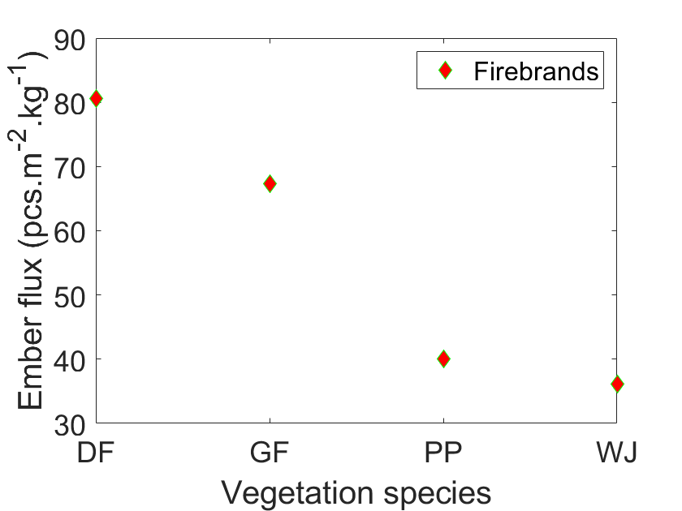

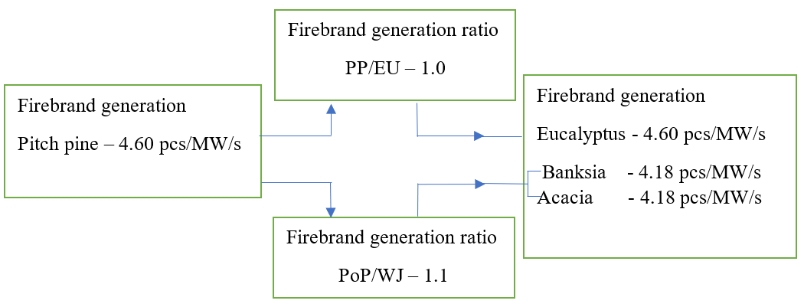

PP-pitch pine

PoP-Ponderosa pine

WJ-Western Juniper

1. FMC

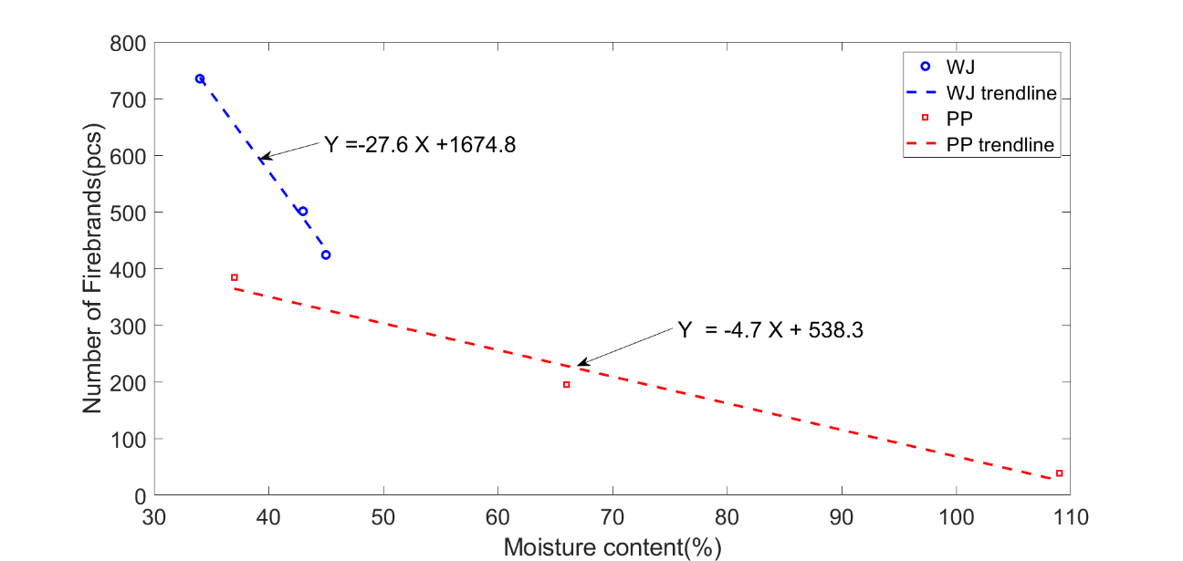

The number of firebrands generated varying the fuel moisture content (FMC) of Western Juniper (WJ) and Ponderosa Pine (PP). Increasing MC results decreasing in firebrand generation. The trend is linear, and it is given the equation of each trendline to find the number of firebrand generation at certain FMC.

Firebrand generation ratio and rate calculation for Eucalyptus, Banksia, and Acacia based on the FMC, trend line equations of WJ, and PP vegetations.

|  |  |  |  |  |  |
| --- | --- | --- | --- | --- | --- |
| Similar  vegetations | Firebrand generation rate  (pcs/MW/s) | MC (%) | Number of firebrands | Generation ratio to  3.22% MC | Generation rate (pcs/MW/s) |
| Western Juniper  Pitch pine  Banksia/Acacia | 4.60  (Picth pine) | 3.84 | 1569 | (1569/819)=1.91 | 4.60🞨1.91=8.79 |
| 31 | 819 | (819/819)=1.00 | 4.60🞨1.00=4.60 |
| Ponderosa pine  Pitch pine  Eucalyptus | 4.60  (Pitch pine) | 3.84 | 520 | (520/392)=1.33 | 4.60🞨1.33=6.12 |
| 31 | 392 | (392/392)=1.00 | 4.60🞨1.00=4.60 |

1. Wind effect

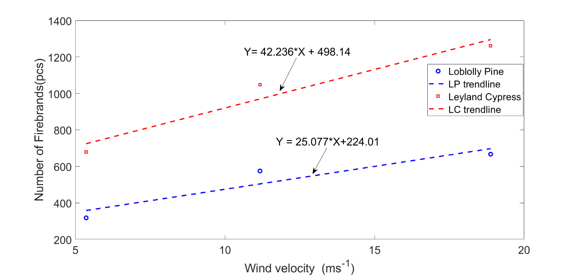

The experimental results of the number of firebrands collected in Idle, medium, and High wind speeds for Loblolly pine and Leyland cypress vegetations. Increasing wind speeds shows an increment of firebrands collection. The experiment was set up to collect all the firebrands generated in each tree burning of Bahrani et al.

Firebrand generation ratio and rate calculation for Eucalyptus, Banksia, and Acacia based on the wind speeds, trend line equations of LP and LC vegetations.

|  |  |  |  |  |  |
| --- | --- | --- | --- | --- | --- |
| Similar vegetations | Firebrand generation rate  (pcs/MW/s) | Wind (m/s) | Number of firebrands | Generation ratio to  2 m/s and 0 m/s | Generation rate (pcs/MW/s) |
| Loblolly pine  Pitch pine  Eucalyptus | 4.60  (Pitch pine at  2 m/s) | 2 | 274 | (274/274)=1.00 | 4.60🞨1.00=04.60 |
| 11.11 | 503 | (503/274)=1.84 | 4.60🞨1.84=08.46 |
| 16.67 | 642 | (642/274)=2.34 | 4.60🞨2.34=10.76 |
| 19.44 | 712 | (712/274)=2.60 | 4.60🞨2.60=11.96 |
| Leyland Cypress  Pitch pine  Banksia/Acacia | 4.60  (Pitch pine  at 2 m/s) | 2 | 583 | (583/583)=1.00 | 4.60🞨1.00=04.60 |
| 11.11 | 967 | (967/583)=1.66 | 4.60🞨1.66=07.64 |
| 16.67 | 1202 | (1202/583)=2.06 | 4.60🞨2.06=09.48 |
| 19.44 | 1319 | (1319/583)=2.26 | 4.60🞨2.26=10.40 |

Combined effect

|  |  |  |  |  |  |  |  |  |  |  |
| --- | --- | --- | --- | --- | --- | --- | --- | --- | --- | --- |
| Vegetation classification | Dominant fuel | Reference firebrand generation (pcs/MW/s)  (Pitch pine) | Effect of (generation ratio) | | | | | Final firebrand generation (pcs/MW/s) | | |
| Species | Wind (m/s) | | | FMC |
| 11.11  (A) | 16.67  (B) | 19.44  (C) | (A) | (B) | (C) |
| Forest | Eucalyptus | 4.60 | 1.00 | 1.83 | 2.34 | 2.60 | 1.33 | 19.2 | 21.5 | 22.7 |
| Scrub | Banksia | 4.60 | 0.91 | 1.66 | 2.06 | 2.26 | 1.91 | 20.6 | 22.4 | 23.4 |
| Mallee/Mulga | Acacia | 4.60 | 0.91 | 1.66 | 2.06 | 2.26 | 1.91 | 20.6 | 22.4 | 23.4 |

Firebrand flux devices

* Complete house
* Roof area only
* Gutter area only
* Understory only
* Door area only
* Front deck area only

|  |
| --- |
|  |

Heat flux devices (Radiative and convective), temperature devices, velocity devices

* Roof front/gutter area (left side, right side, and the middle)
* Roof top (left side, right side, and the middle)
* Middle of the roof
* Deck front (left side, right side, and the middle)
* Understory front (left side and right side)
* Middle area of the understory
* Front wall (left side and the right side)
* Door
* Back wall (left side, right side, and the middle)

|  |
| --- |
|  |

Firebrand flux vertical planes (kg/m2/s)

* Records the integrated mass flux of all particles passing through the given vertical plane.
* Locations at 130 m, 140 m, 150 m, 160 m, 170 m, 180 m, 190 m, 200 m, 210 m

Ex:

&DEVC XB= 150.0, 150.0, -51.0, 51.0, 0.0, 90.0, ID='flux150', QUANTITY='PARTICLE FLUX X', STATISTICS='AREA INTEGRAL' /

|  |
| --- |
|  |

Results

|  |  |  |  |  |  |  |  |
| --- | --- | --- | --- | --- | --- | --- | --- |
| Location | Area (m2) | FDI 100 BAL 12.5 | | | FDI 100 BAL 19 | | |
| Firebrands  (pcs) | Density  (pcs/m2) | Flux  (pcs/m2/s) | Firebrands  (pcs) | Density  (pcs/m2) | Flux  (pcs/m2/s) |
| Complete House | 304 | 63676 | 209.6 | 3.678 | 63768 | 209.9 | 3.888 |
| Roof | 304 | 56062 | 184.6 | 3.927 | 49907 | 164.3 | 3.496 |
| Gutter | 32 | NA | NA | NA | 8003 | 254.1 | 6.351 |
| Understory | 284 | 1613 | 5.69 | 0.102 | 3263 | 11.5 | 0.213 |
| Deck | 32 | 2378 | 75.49 | 1.348 | 6154 | 195.4 | 3.907 |

Firebrand distribution in x direction.

|  |
| --- |
|  |
|  |

|  |
| --- |
|  |
|  |
|  |
|  |

|  |
| --- |
|  |
|  |

1. Alexander, M.E. and M.G.J.I.J.o.W.F. Cruz, *Interdependencies between flame length and fireline intensity in predicting crown fire initiation and crown scorch height.* 2012. **21**(2): p. 95-113.

2. Wotton, B.M., et al., *Flame temperature and residence time of fires in dry eucalypt forest.* 2012. **21**(3): p. 270-281.